**HALF SUBTRACTOR USING NAND GATES ONLY**

**EXP NO.6:**

AIM: To show the working of half subtractor of NAND gates only using logisim.

Truth table:

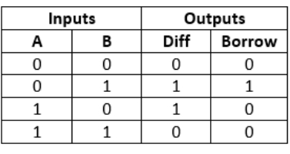

OUTPUT:

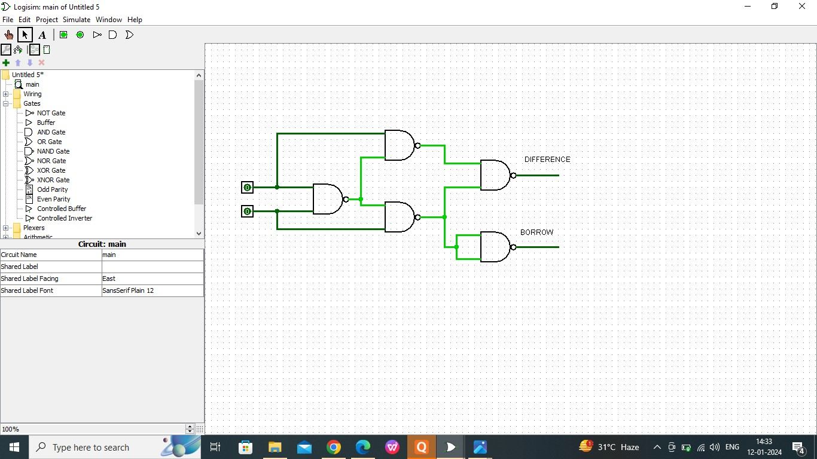

RESULT:

Thus the working of half subtractor has been observed successfully using logisim